**Lab Objectives**

* Linear Programming with Excel Solver
* Financial Functions

**Exercise # 1**

Maze Furniture makes tables and chairs that have to be processed through two machines, M1 & M2. The time in hours required to make one table and one chair are given in the below table.

|  |  |  |
| --- | --- | --- |
| Machine | Table | Chair |
| M1 | 7 | 4 |
| M2 | 5 | 5 |

A total of 200 hours are available on M1 and 400 hours on M2. The profit of selling a chair is $30 and selling a table is $40. Determine the optimal number of tables and chairs to be produced to maximize the profit.

1. Decision? No. of tables??, no. of chairs??
2. Goal/Objective? Max profit
3. Limitations/Boundaries/Constraints:

**Answer**

* Decision Variables: Let X be the number of tables produced and Y be the number of chairs produced.
* Objective Function: Max. 40X + 30Y
* Constraints:

7X + 4Y ≤ 200

5X + 5Y ≤ 400

X, Y ≥ 0 Non negativity

Once, the formulation is written on excel, open the solver from the Data tab.

After entering the objective function and the constraints, make sure that you choose Simplex LP method as we are dealing with linear programming problems and then, click solve.

**NB:** Don’t forget the non-negativity constraint

**Exercise # 2 (Transportation problem)**

|  |  |  |  |  |
| --- | --- | --- | --- | --- |
|  | **Warehouse 1** | **Warehouse 2** | **Warehouse 3** | **Supply** |
| **Factory 1** | 5 | 4 | 3 | 100 |
| **Factory 2** | 8 | 4 | 3 | 300 |
| **Factory 3** | 9 | 7 | 5 | 300 |
| **Demand** | 300 | 200 | 200 | 700 |

Given the cost per each path, Find the optimal amount of shipments in order to minimize the total transportation cost.

1. D.V: 9 dv Xi,j
2. O.F Min Cost Min. 5X11 + 4X12 + 3X13 + 8X21 + 4X22 + 3X23 + 9X31 + 7X32 + 5X33
3. Constraints:
   1. Supply
      1. x11+x12+x13<=100
      2. x21+x22+x23<= 300
      3. x31+x32+x33<= 300
   2. Demand
      1. x11+x21+x31=300 warehouse 1
      2. x12+x22+x32= 200 warehouse 2
      3. x13+x23+x33= 200 warehouse 3

xi,j >=0

**Answer**

* Decision Variables: Let Xij be the amount shipped from factory i to warehouse j
* Objective Function: Min. 5X11 + 4X12 + 3X13 + 8X21 + 4X22 + 3X23 + 9X31 + 7X32 + 5X33
* Constraints:

X11 + X12 + X13 ≤ 100

X21 + X22 + X23 ≤ 300

X31 + X32 + X33 ≤ 300

X11 + X21 + X31 = 300

X12 + X22 + X32 = 200

X13 + X23 + X33 = 200

Xij ≥ 0

Therefore, the following figure shows the optimal values of the decision variables and the objective function.

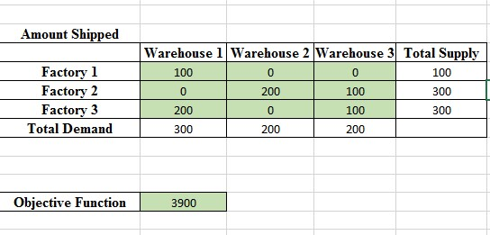

**Exercise # 3**

Solve the following system of linear equations using the Solver. $$4x+y-2z=0 \\ 2x-3y+3z=9 \\ -6x-2y+z=0$$ 
**NB:** Choose the L.H.S. of any equation as the objective function (Max or Min it will not differ due to the strictly equality constraints)

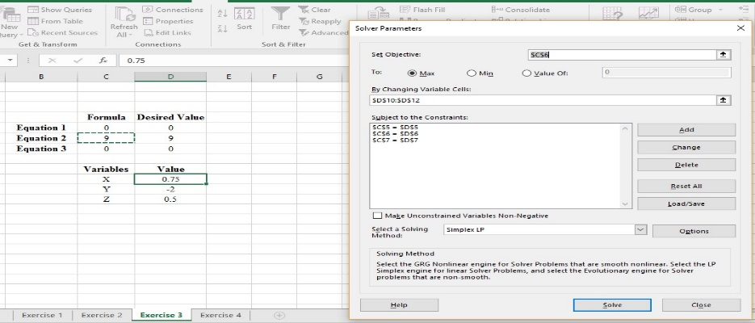

**Exercise # 4**

